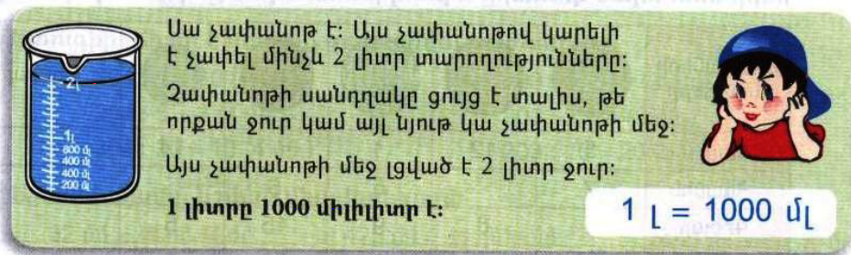
Դասարանական առաջադրանքներ
1․ Արտահայտի՛ր միլիլիտրով։
3լ450մլ = 3450մլ
42լ50մլ = 42050մլ
7լ700մլ = 7700մլ
2․ Արտահայտի՛ր լիտրով և միլիլիտրով։
2500մլ = 2լ500մլ
20020մլ = 20լ20մլ
4050մլ = 4լ50մլ
3․ Երկու անոթներում կա 1լ ջուր։ Անոթներից մեկում կա 4 անգամ ավելի ջուր, քան մյուսում։ Որքա՞ն ջուր կա յուրաքանչյուր անոթում։ Առաջին Անոթ – 800մլ Երկրորդ Անոթ – 200մլ
4․ Արայի մոտ կա 50 և 20 դրամանոց ընդհանուր թվով 26 մետաղադրամ։ Այդ մետաղադրամների ընդհանուր գումարը 940դրամ է։ Արան քանի՞ 50 և քանի՞ 20 դրամանոց մետաղադրամ ունի։ 50 դրամանոց - 14 20 դրամանոց - 12
5․ Կարենի մտապահած քառանիշ թիվը միաժամանակ պատիկ է և՛ 2-ին, և՛ 5-ին, իսկ թվանշանների գումարը 27 է։ Ո՞րն է այդ թիվը։ 99903

Տնային առաջադրանքներ
1․ Արտահայտի՛ր միլիլիտրով։
48լ7մլ = 48007մլ
7լ77մլ = 7077մլ
77լ7մլ = 7707մլ
2․ Արտահայտի՛ր լիտրով և միլիլիտրով։
4004մլ = 4լ4մլ
3000մլ = 3լ
20005մլ = 20լ5մլ
3․ Երկու անոթներում կա 2լ ջուր։ Անոթներից յուրաքանչյուրում կա 4 անգամ ավելի ջուր, քան մյուսում։ Որքա՞ն ջուր կա յուրաքանչյուր անոթում։ Առաջին Անոթ – 1լ600մլ Երկրորդ Անոթ – 400մլ
4․ Հայկի մոտ կա 500 և 200 դրամանոց ընդհանուր թվով 25 մետաղադրամ։ Այդ մետաղադրամների ընդհանուր գումարը 9200դրամ է։ Հայկը քանի՞ 500 և քանի՞ 200 դրամանոց մետաղադրամ ունի։ 500 դրամանոց – 14 200 դրամանոց – 11
5․ Բացահայտի՛ր օրինաչափությունը և շարունակի՛ր։
20, 22, 26, 32, 40, 50, 62, 76, 92, 110, 130, 152, 176:
80, 78, 74, 68, 60, 50, 38, 24, 8:

